**DAILY ONLINE ACTIVITIES SUMMARY**

|  |  |  |  |  |  |  |  |  |
| --- | --- | --- | --- | --- | --- | --- | --- | --- |
| **Date:** | **10-06-2020** | | | | | **Name:** | **pallavi** | |
| **Sem & Sec** | **6th sem ‘A’ sec** | | | | | **USN:** | **4al17cs056** | |
| **Online Test Summary** | | | | | | | | |
| **Subject** | | **SSCD** | | | | | | |
| **Max. Marks** | | **30** | | **Score** | | | **29** | |
| **Certification Course Summary** | | | | | | | | |
| **Course** | **Python for machine learning** | | | | | | | |
| **Certificate Provider** | | | **Great learning academy** | | **Duration** | | | **5hr** |
| **Coding Challenges** | | | | | | | | |
| **Problem Statement:**  1.1.Write a C Program to print the sum of boundary elements of a matrix  2.Write a Java program to find the maximum and minimum value node from a circular linked list  3.Python Program to check whether a given number is a fibonacci number or not | | | | | | | | |
| **Status:completed** | | | | | | | | |
| **Uploaded the report in Github** | | | | | **yes** | | | |
| **If yes Repository name** | | | | | <https://github.com/pallavi056/DAILY_STATUS> | | | |
| **Uploaded the report in slack** | | | | | **yes** | | | |

Online Test Details:

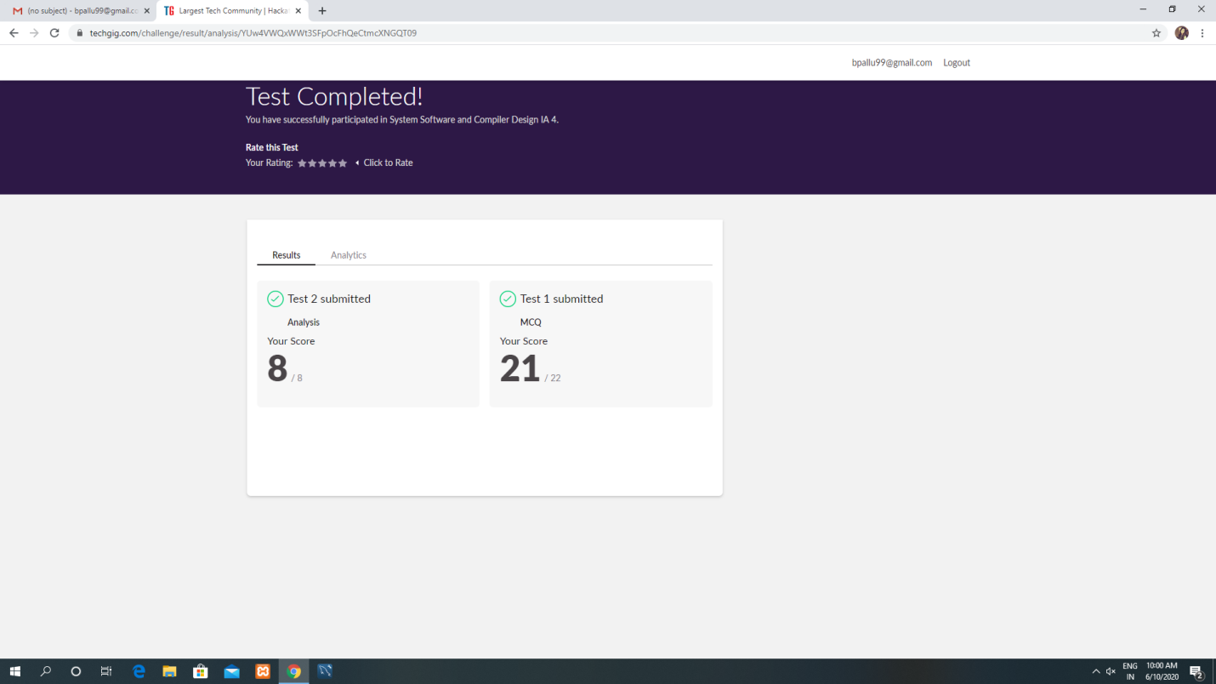

Certification Course Details:

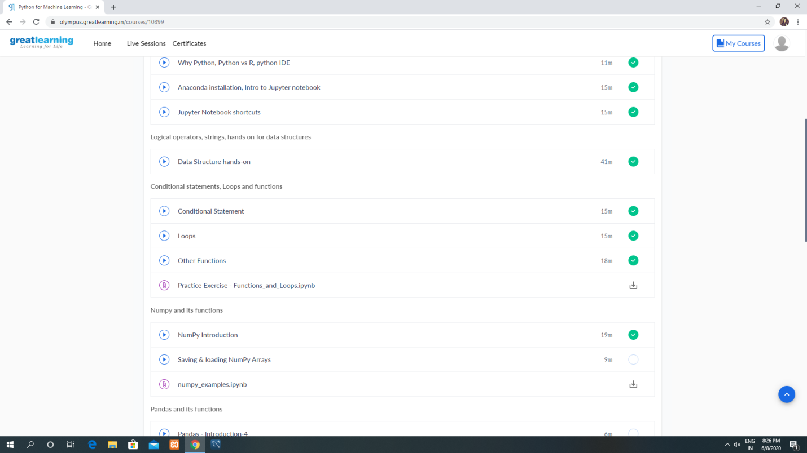

Coding Challenges Details:

[https://github.com/pallavi056/DAILY_STATUS/tree/master/10-06-2020/ONLINE%20CODING](https://github.com/pallavi056/DAILY_STATUS/tree/master/10-06-2020/ONLINE CODING)